**BEANSIGHT: WEB BASED AND MOBILE APPLICATION WITH   
DATA ANALYTICS FOR SOL-ACE CAFE IN KAWIT**

Undergraduate Capstone Project

Submitted to the Faculty of the

Cavite State University - Imus Campus

Imus, Cavite

In partial fulfillment  
Of the requirements for the degree of  
Bachelor of Science in Information Technology

**GERANDY ERNEST J. BUENSUCESO**

**FERDINAND V. OLAIRA JR.**

**ERWIN M. VALLEZ**

January 2026

# BIOGRAPHICAL DATA

**Gerandy Ernest J. Buensuceso** is a 4th-year IT student at Cavite State University - Imus Campus. Born on December 9, 2004, he is currently 20 years old and resides in Batong Dalig, Kawit, Cavite. In the "BeanSight" capstone project, his role is a programmer specializing in the backend process.

**BIOGRAPHICAL DATA**

**Ferdinand Villamor Olaira Jr.** was born on April 12, 2004. He currently resides in Malagasang 2-B, Imus City, Cavite, with his family. He is the second child among the six children of Rubilyn Olaira and Ferdinand Olaira

He completed his primary education at Malagasang 2-B Elementary School in Imus City, Cavite. He pursued his secondary education at General Tomas Mascardo National High School in Imus City, Cavite.

In 2022 He enrolled in Cavite State University-Imus Campus, Pursuing a Bachelor of Science in Information Technology.

He wanted to pursue a career as a Network Engineer in the future.

**BIOGRAPHICAL DATA**

**Erwin M. Vallez** was born on November 24, 2003. He currently resides in Molino IV, Bacoor City, Cavite, with his family. He is the youngest child among the 7 children of Elizabeth Vallez and Enrico Vallez

He completed his primary education at Pamplona Elementary School Central in Las Piñas City. He pursued his secondary education at Las Piñas East National High School in Las Piñas City.

In 2022 He enrolled in Cavite State University-Imus Campus, Pursuing a Bachelor of Science in Information Technology.

He wanted to pursue a career as a Web Developer in the future.

# ACKNOWLEDGEMENT

The authors would like to extend their warmest thanks and gratitude to the following persons who had been part of the conduct of this study:

Ma'am Sherilyn Fajutagana, capstone project adviser, for the guidance, comments, and suggestions that contributed to the successful completion of the study, especially in the development and refinement of the system;

Mrs. Gizelle Rodero, technical adviser, for providing insightful evaluations and technical recommendations that helped improve the overall quality of the project;

Ms. Grace Ibañez, department chairperson of the Department of Computer Studies, for her support and consideration throughout the completion of this capstone project;

The owner and staff of Sol-Ace, for their cooperation, openness, and assistance during on-site observations, and data gathering;

Their classmates from BSIT 4th year and their friends, for the encouragement, shared ideas, and constant support throughout the development of the project;

Their families, for their unwavering love, understanding, and continuous moral and financial support that motivated the authors to accomplish this study; and

The Almighty God for granting them wisdom, strength, and perseverance throughout the challenges faced during the development of this study. His guidance has been their source of hope and determination from beginning to end.

**THE AUTHORS**

# ABSTRACT

**BUENSUCESO, GERANDY ERNEST J., VALLEZ, ERWIN M.,** and **OLAIRA, FERDINAND JR. V.**. **Beansight: A Web-Based and Mobile Application with Data Analytics for Sol-Ace Cafe in Kawit**. Undergraduate Capstone Project. Bachelor of Science in Information Technology. Cavite State University, Imus Campus, Imus, Cavite. January 2026. Adviser: Mrs. Sherilyn F. Fajutagana.

The study was conducted from May 2025 to January 2026 at Sol-Ace Café in Kawit, Cavite. Specifically, the study aimed to (1) design and develop a unified web and mobile application that facilitates online ordering, POS transactions, real-time order status tracking, and dynamic sales reporting; (2) develop the application using JavaScript as the programming language, React and Tailwind CSS for frontend development, and Firebase for the backend database and hosting; (3) test the system in terms of unit, integration, and system testing; (4) evaluate the system using the adapted ISO 25010 evaluation instrument; and (5) prepare an implementation plan.

The researchers used the Agile methodology. The application was designed and developed using Visual Studio Code, React, and Firebase. The Beansight application was successfully developed and tested, achieving seamless real-time synchronization between the customer ordering interface, the staff POS, and the admin dashboard. Furthermore, the application was evaluated by 50 respondents, composed of the business owner and customers, using the adapted ISO 25010 model as the evaluation instrument.

The results yield a 4.46 mean rating, which has an equivalent descriptive rating of **“Very Good.”** This proves that the application is effective and ready to enhance the operational efficiency and customer experience of Sol-Ace Café.

# TABLE OF CONTENTS

**Pages**

BIOGRAPHICAL DATA i

ACKNOWLEDGEMENT iv

ABSTRACT v

TABLE OF CONTENTS vi

LIST OF TABLES viii

INTRODUCTION 1

Project Context 2

Objectives of the Study 3

Purpose and Description 4

Time and Place of the Study 5

Scope and Limitation of the Study 5

Conceptual Framework 7

Definition of Terms 8

REVIEW OF RELATED LITERATURE 9

Related Literature 9

Related Studies 11

Systems Technical Background 12

Synthesis 14

METHODOLOGY 16

Design of Software, Systems, Product and/or Process 16

System Development 23

System Testing 24

System Evaluation 25

Implementation Plan 28

RESULTS AND DISCUSSION 30

System Design 30

System Development 36

System Testing 38

System Evaluation 42

SUMMARY, CONCLUSIONS, AND RECOMMENDATIONS 50

Summary 50

Conclusion 50

Recommendation 51

REFERENCES 52

# LIST OF TABLES

**Table Pages**

**Table 1.** Table of comparison 15

**Table 2.** Technical Resources 20

**Table 3.** Estimated Cost of the Project 20

**Table 4.** Module and Features of the Proposed System 21

**Table 5.** Non-Functional Requirements of the System 22

**Table 6.** 5-point Likert Scale 26

**Table 7.** Descriptive interpretation of the mean 26

**Table 8.** Implementation Plan of Beansight 29

**Table 9.** Sprint Cycle 37

**Table 10.** Summary of Module Functionality Testing 39

**Table 11.** Integration Testing Results 41

**Table 12.** Survey Respondents 42

**Table 13.** General Rating on Functionality 43

**Table 14.** General Rating on Reliability 44

**Table 15.** General Rating on Usability 45

**Table 16.** General Rating on Efficiency 46

**Table 17.** General Rating on Maintainability 47

**Table 18.** General Rating on Portability 48

**Table 19.** General Rating on Overall Satisfaction 49

**LIST OF FIGURES**

**Table Pages**

**1** Conceptual Framework 7

**2** Context Diagram for Beansight 17

**3** Use Case Diagram for Beansight 18

**4** Manual Ordering Processing in Sol-Ace Cafe 19

**5** Agile Model (asana, 2025) 23

**6** System Architecture 30

**7** NoSQL Database Diagram of the System 31

**8** Customer Menu Interface 32

**9** Checkout Page 33

**10** Order Tracking Interface 33

**11** Point of Sale (POS) Interface 34

**12** Kitchen Display System 35

**13** Admin Analytics Dashboard 35

**BEANSIGHT: WEB BASED AND MOBILE APPLICATION WITH   
DATA ANALYTICS FOR SOL-ACE CAFE IN KAWIT**

**Buensuceso, Gerandy Ernest J.**

**Olaira Jr., Ferdinand V.**

**Vallez, Erwin M.**

An undergraduate capstone project manuscript submitted to the faculty of the Department of Information Technology, Cavite State University, Imus, Cavite in partial fulfillment of the requirements for the degree of Bachelor of Science in Information Technology. Contribution No. . Prepared under the supervision of Mrs. Sherilyn Fajutagana.

# INTRODUCTION

In a time where digital innovation is reshaping customer behavior, the importance of developing a reliable and optimized ordering system continues to grow particularly for small businesses like Sol-Ace Cafe in Kawit. As consumer demand leans more toward convenience, speed, and personalization, cafés are increasingly expected to adapt by offering more streamlined and accessible services.

Traditional methods of handling orders, managing sales, and tracking performance are becoming less effective in addressing these modern demands. Manual processes often lead to delays, errors, and limited insight into customer preferences and business performance. This growing challenge highlights the need for a system that not only simplifies transactions but also provides meaningful data to guide decision-making.

To address this, the proposed project introduces Beansight, a web-based and mobile application designed to enhance both customer interaction and operational management for Sol-Ace Cafe. The system will feature a user-friendly online ordering interface, detailed sales reporting dashboards, and multi-channel integration that connects online and in-store transactions.

## Project Context

The primary problem of this research is to explore how digital solutions can improve the overall operations of coffee shops, particularly focusing on Sol-Ace Cafe in Kawit. Specifically, this study aims to examine how a unified system for online ordering, Point of Sale (POS), sales reporting, and order status tracking can support the digital growth of the business. Beansight seeks to understand the necessary features that will create a seamless and user-friendly platform tailored to both the business and its clientele.

Beansight will provide insight into designing a web and mobile application based on the actual needs of the owner and the business. It aims to simplify the process of ordering various food and beverage items, ensure smooth POS transactions, generate sales reports, and provide order status tracking for the customers.

To address these needs, Beansight: A Web-Based and Mobile Application with Data Analytics for Sol-Ace Cafe in Kawit was conceptualized. Ensuring integration of the ordering, POS, analytics dashboard, and order status tracking features into a single cohesive system can be a complex task. Each module must communicate in real-time to avoid discrepancies in sales records, order details, and customer data. Moreover, customers who are unfamiliar with digital platforms may encounter difficulty navigating the system, which highlights the need for a simplified interface. On the other hand, staff members will also require proper training to handle the system, especially in terms of managing orders, and operating the POS.

## Objectives of the Study

The objective of the study is to develop and implement a web-based and mobile application with integrated ordering, POS, and sales reporting features to enhance operational efficiency and customer experience for Sol-Ace Cafe.

Specifically, it aims to:

1. design a user-friendly online ordering system that;

1. enables the customer to browse the menu, track the status of their orders,
2. facilitate flexible payment options including cash and digital wallets;
3. sync online and instore sales;
4. generate clear sales reporting;
5. allow admins to manage orders, inventory, products, staff accounts, and system configuration;
6. allow the admin page to generate a dynamic sales reporting; dashboard that provides real-time insights into revenue, and top-selling items; and
7. allow staff to handle in-store and online orders, set availability to products, and add inventory items

2. develop the application using the following;

1. javascript for programming language;
2. react and Tailwind for Frontend development;
3. firebase for database and hosting; and
4. visual Studio Code for programming interface

3. test the system in terms of modules, integration, and system testing; and

4. Implement the system

## Purpose and Description

The main purpose of this study is to create Beansight, a web-based and mobile application that will help improve the daily operations and customer experience of Sol-Ace Café in Kawit. The researchers made this project to help the café move toward digital solutions that make work more organized.

This study aims to develop a system that combines online ordering, Point of Sale (POS), sales reports, and order status tracking in one platform. Through this project, the researchers want to make ordering easier for customers and help the staff manage their tasks more efficiently.

For customers, the system will allow them to view the menu, place their orders, and check their order status online. For the café management, it will provide tools to record sales, track orders, generate reports, and configure system settings that can help them make better business decisions.

The project is expected to benefit Sol-Ace Café by improving its service quality, saving time, and reducing errors in order taking and sales reporting. It will also add to the growing use of technology in small local businesses. Beansight is innovative because it combines several important features into one system.

## Time and Place of the Study

The study was conducted at Sol-Ace Café, located in Kawit, Cavite, during the Academic Year 2025–2026. The development, testing, and evaluation of the proposed Web-Based and Mobile Application for Sol-Ace Café were carried out within this period to enhance the café’s ordering and management processes. This location served as the primary setting for observing the existing manual operations, gathering user feedback, and implementing the system in a real business environment to improve efficiency and customer experience.

## Scope and Limitation of the Study

This study focuses on the development and implementation of Beansight, a web-based and mobile application designed to support and enhance the operations of Sol-Ace Cafe, a local café in Kawit. The website and mobile application will include the following core modules:

1. **Ordering Module** – Allows customers to browse the menu, and place them for pick-up or delivery. It includes features for viewing item categories such as coffee-based, non-coffee, and frappe drinks.
2. **Point of Sale (POS) Module** – Enables café staff to process walk-in with real-time synchronization, supporting payment options such as cash
3. **Sales Reporting and Analytics Module** – Provides real-time sales dashboards and exportable reports, displaying key metrics such as revenue, top-selling items, and customer purchasing behavior to support data-driven decision-making.
4. **Order Status Tracking Module** – Allows both staff and customers to view the real-time status of orders from confirmation to completion, improving transparency and customer convenience.
5. **Multi-Channel Integration** – Ensures consistent and synchronized operations between online and in-store systems, unifying data across all sales channels.
6. **Kitchen Display System** - It functions as a live order queue accessible by the Cafe staff to know incoming online orders.

This study is limited to the design and implementation of the system exclusively for Sol-Ace Cafe. User access will be limited to basic roles (admin, staff, and customer). Additionally, while basic data analytics will be implemented through the sales reporting and data analytics module, more complex predictive analytics and AI-based recommendations are beyond the current scope.

## Conceptual Framework

**Figure 1.** Conceptual Framework

## Definition of Terms

The following terms are operationally defined in the study:

**Multi-Channel Integration** – The coordination of various sales platforms (such as online and in-store systems) into one unified system to provide consistent data and a seamless customer experience.

**Order Status Tracking** – A system feature that allows customers and staff to monitor the status of an order in real-time, from order placement to completion.

**Point of Sale (POS)** – A system used to complete sales transactions. In this study, the POS module enables Sol-Ace Cafe to manage both online and walk-in orders with real-time data synchronization.

**Sales Reporting** – The process of collecting, analyzing, and presenting sales data. This module provides visual reports on revenue, top-selling items, and customer trends to support decision-making.

**User Interface (UI)** – The visual elements of a system that users interact with, such as buttons, menus, and layouts. A good UI ensures ease of use and accessibility for both customers and staff.

**Web-Based Application** – A software application that runs on a web browser and does not require installation on a device. In this study, it refers to the desktop-accessible version of Beansight used for ordering and management

# REVIEW OF RELATED LITERATURE

## Related Literature

Samoggia et al. (2021) conducted a systematic review that emphasized the role of digital technologies, especially mobile applications, as valuable instruments for strengthening relationships among actors in the food supply chain and effectively promoting urban and regional food systems. Their findings highlight the ability of dedicated digital tools to enhance networking and provide information within local ecosystems. This framework directly applies to the goals of Beansight. By developing a unified and tailored platform for Sol-Ace Café in Kawit, Beansight aims to serve as the necessary digital tool to strengthen the connection between this local business and its specific consumer base, thereby supporting the café’s digital growth and promoting its products within the local community.

Maulana (2023) conducted a proposal review that highlighted the clear necessity for a unified mobile app tailored specifically for coffee shop operations and the ordering experience. The research emphasizes that a dedicated platform is crucial to address the unique demands of these establishments, such as extensive beverage customization, and to streamline ordering, minimize errors, and improve overall operational efficiency. Beansight reflects this same principle by developing a single, customized platform for Sol-Ace Café, directly addressing the gap identified by Maulana and validating the project's focus on managing the complexities of coffee shop transactions, ensuring both high operational efficiency and an enhanced customer experience.

Smith (2022) studied the Buy-Online-Pick-Up-In-Store (BOPIS) strategy and found that perceived usefulness and ease of use were major contributors to customer satisfaction in hybrid online–offline systems. This supports Beansight’s vision of offering a cohesive platform that integrates online transactions with in-store café operations, ensuring flexibility and convenience for both customers and staff.

Buenaventura et al. (2021) created a mobile ordering application for fast-food restaurants that utilized the Agile methodology to reduce customer wait times and improve service speed. Their study demonstrated that adopting a fast-iteration, customer-focused development process can lead to improved service speed and overall user satisfaction. These results establish the principle of process efficiency in mobile ordering systems, which mirrors Beansight’s objective of providing fast, responsive, and convenient service to enhance customer experience and operational productivity.

Madani and Alshraideh (2021) explored how machine learning models, including decision trees, random forests, and SVMs, can accurately predict customer purchasing behavior in online food delivery platforms. With accuracy exceeding 90%, their study highlighted the potential of analytics in personalizing user experiences and anticipating customer needs. This supports Beansight’s integration of data-driven sales reporting and behavior analysis to enhance customer engagement and promote repeat purchases.

Almonteros et al. (2024) examined the Food Panda application using ECM and TAM and found that customer perception and e-satisfaction directly influenced intention to continue using the app. Their findings reinforce Beansight’s focus on providing consistently high service quality, seamless usability, and positive user experience to encourage long-term usage and customer loyalty.

## Related Studies

Jiangmin (2021) developed a web-based food ordering system that replaced manual restaurant processes through automated menu management and order handling. The study demonstrated how digital systems increase accuracy and efficiency in daily operations. Beansight reflects this same principle by integrating online ordering, POS, and analytics to simplify Sol-Ace Café’s workflow and reduce errors caused by manual processes.

Babasa et al. (2025) created COSY, a SaaS-based online ordering system for school canteens that improved order processing speed and user convenience through cloud-based management. This parallels Beansight’s digital approach to streamlining café operations through accessible and efficient cloud-supported solutions.

Rombach et al. (2023) analyzed customer loyalty in food delivery services across Indonesia, Taiwan, and New Zealand using PLS-SEM. They identified food quality, e-service quality, customer satisfaction, and trust as key drivers of loyalty. Beansight adopts similar principles by ensuring reliable system performance and an engaging user interface to build trust and encourage repeat interactions.

Dela Peña and Aquino (2023) investigated perceptions of self-service kiosks in fast-food restaurants and found that perceived usefulness and ease of use influenced willingness to adopt kiosk technology, though accessibility and security concerns were also noted. Beansight addresses these concerns by implementing secure, inclusive, and user-friendly interfaces for both mobile and web platforms.

Londoño-Giraldo et al. (2024) studied engagement and loyalty in food-delivery mobile applications during the COVID-19 pandemic using structural equation modeling. They found that convenience, interactivity, and perceived safety significantly improved user engagement. These insights align with Beansight’s aim to provide a seamless digital experience with accurate tracking, real-time updates, and an interface designed for trust and convenience.

Samaniego et al. (2022) examined the issue of customer retention in digital food services, focusing on which dimensions of the mobile food delivery application (MFDA) experience influence a customer’s reuse intention during the COVID-19 pandemic. Their findings identified perceived usefulness and ordering satisfaction as the two most significant factors driving a customer's intention to continue using an application. Beansight reflects this same principle by focusing on creating a highly useful, efficient, and satisfactory ordering process, directly aligning the project with established drivers of customer loyalty and retention in the digital food service industry.

Wikamulia & Isa (2023) focused on the implementation of a predictive Business Intelligence (BI) dashboard for food and beverage businesses that deal with fast-expired goods. The research successfully demonstrated that a predictive BI dashboard which performed demand forecasting and customer segmentation helped businesses accelerate the decision-making process, implement a data-driven system, and discover new business insights. Beansight reflects this same principle by integrating a data analytics dashboard. This integration will provide Sol-Ace Café with the capability for data-driven sales reporting and behavior analysis, ensuring that the ordering system's data is immediately utilized to manage inventory, forecast demand, and improve overall operational efficiency.

## Systems Technical Background

Beansight is designed as an integrated web-based and mobile application that provides data analytics capabilities to enhance the operational efficiency of Sol-Ace Café. The system applies various modern technologies to support functionalities such as sales monitoring, inventory tracking, and data-driven decision-making.

**Cloud Integration.** To ensure scalability and accessibility, Beansight can be deployed on a cloud-based platform such as Firebase. Cloud hosting enables real-time synchronization between web and mobile applications, data backup, and high availability of services even during peak café operations.

**Data Analytics.** The system integrates data analytics tools that process and visualize information to generate meaningful insights. Techniques such as data aggregation, filtering, and graphical representation are used to identify trends in sales performance, top-selling products, and customer preferences. These analytical features aid management in making informed business decisions.

**Database Management System (DBMS).** Beansight employs a NoSQL document-oriented database system, specifically Cloud Firestore, to handle data storage and retrieval efficiently. Unlike traditional relational databases, Firestore stores data in flexible documents and collections, allowing for scalable storage of sales transactions, product inventories, and customer records. This structure enables real-time data synchronization across client devices without the need for complex joins, ensuring high performance and data availability.

**Security and Authentication.** The system utilizes Firebase Authentication to manage user access securely. This service provides reliable and easy-to-implement authentication features using email and password login, ensuring that only authorized users can access the system’s administrative functions. Firebase automatically handles the encryption and secure transmission of user credentials, protecting sensitive information from unauthorized access. In addition, data exchanged between the client and the server is safeguarded through HTTPS protocols, ensuring secure communication throughout the system.

**Web and Mobile Technologies.** The system utilizes web development technologies such as TAILWIND CSS, and REACT to create an interactive and responsive user interface. These technologies ensure accessibility, responsiveness, and usability across different platforms.

## Synthesis

The reviewed literature establishes robust empirical and conceptual foundations across three critical areas: operational efficiency, customer loyalty models, and predictive analytics. Studies confirm that system development should adhere to principles like perceived usefulness (e.g., Smith, 2022) and e-satisfaction (e.g., Almonteros et al., 2024; Samaniego et al., 2022) to drive customer retention, while operational systems must utilize methodologies like Agile (Buenaventura et al., 2021) and be digitally managed for accuracy and efficiency (Jiangmin, 2021). Furthermore, the conceptual framework for leveraging machine learning models to predict customer behavior (Madani and Alshraideh, 2021) and the successful implementation of Business Intelligence (BI) dashboards (Wikamulia & Isa, 2023) highlight the necessity of data-driven decision-making in the food industry.

Despite this strong body of work, a significant gap exists because these solutions remain scattered and not unified into a single cohesive platform specifically tailored for small café operations. To address this, Beansight: A Web-Based and Mobile Application with Data Analytics for Sol-Ace Café in Kawit introduces a distinct, unified, and multi-channel system. This innovation integrates the Ordering Module, Point of Sale (POS), and Analytics Module seamlessly, directly addressing the established need for efficiency and a tailored solution (Maulana, 2023). By providing a single source for all sales data (in-store and online), Beansight enables the café owner to move beyond manual processes and make integrated, data-driven decisions while enhancing customer experience, thereby supporting the digital growth of this local SME.

**Table 1.** Table of comparison

|  |  |  |  |  |  |  |  |
| --- | --- | --- | --- | --- | --- | --- | --- |
| **RELATED STUDIES TITLE** | **DWFOS** | **IMFD ECRIC** | **DCLOFSD** | **AACP SOK** | **PBID** | **ELM ARHD** | **COSY OWAS** |
| **YEAR** | **2021** | **2022** | **2023** | **2023** | **2023** | **2024** | **2025** |
| **MODULES:** |  |  |  |  |  |  |  |
| **Ordering Module** | *I* | *I* | *X* | *X* | *X* | *I* | *I* |
| **Multi-Channel**  **Integration** | *I* | *I* | *X* | *X* | *X* | *I* | *I* |
| **Sales & Reporting Analytics** | *X* | *X* | *X* | *X* | *I* | *X* | *I* |
| **Order Status Tracking** | *X* | *X* | *X* | *X* | *X* | *X* | *X* |

**LEGENDS:**

**DWFOS -** Development of a web-based food ordering system

**IMFD ECRIC -** Influence of mobile food delivery experience on customer reuse intention during the COVID-19 pandemic

**DCLOFSD -** Determinants of customer loyalty to online food service delivery: Evidence from Indonesia, Taiwan, and New Zealand

**AACP SOK -** An analysis of customer perception on self-ordering kiosks of fast-food restaurants in San Pablo City, Laguna

**PBID -** Predictive business intelligence dashboard for food and beverage business

**ELM ARHD -** Engagement and loyalty in mobile applications for restaurant home deliveries

**COSY OWAS -** COSY:An ordering web application system for school canteens

# METHODOLOGY

This chapter includes the design of software, systems, products, or process, system development, system testing and evaluation, data analysis and implementation plan of the study.

## Design of Software, Systems, Product and/or Process

The design of the Beansight system follows a modular architecture organized into three primary user interfaces: the Customer-Facing Ordering Interface, the Staff POS and Kitchen Display Interface, and the Administrative Management Interface. This structure organizes the core modules listed in the scope of the study to ensure a clear separation of roles while maintaining real-time synchronization across all operations of Sol-Ace Café.

The Customer-Facing Ordering Interface incorporates the Ordering and Order Status Tracking Modules. It serves as the main portal for customers, allowing them to browse the menu, and place orders for pickup or delivery. Once an order is placed, the system automatically transmits the details to the staff in real-time. This interface ensures a seamless user experience while supporting accurate order transmission.

The Staff POS and Kitchen Display Interface consolidate the operational tools for the service staff. It houses the Point of Sale (POS) Module for processing walk-in transactions and payments. Additionally, it integrates the Kitchen Display System (KDS), which functions as a live digital queue for incoming online orders. This component ensures that the Multi-Channel Integration objectives are met by keeping front-of-house and kitchen operations synchronized.

The Administrative Management Interface contains the Sales Reporting and Analytics Module. Accessible only to the owner and authorized users, this component provides full control over inventory management, including menu updates and price adjustments. It features the analytics dashboard that visualizes the data collected from the other modules, providing insights into total revenue, sales trends, and customer behavior to support data-driven decision-making.

The system is developed using JavaScript, utilizing React with Tailwind CSS to deliver a responsive and intuitive interface for both customer and staff users. All data, including menu information, user accounts, order records, and sales logs, is stored and synchronized using Firebase, which also handles hosting and authentication. Development is carried out through Visual Studio Code, ensuring organized and efficient implementation across all modules of the application. Figures 2 and 3 below presents the Context and Use Case Diagram for Beansight.

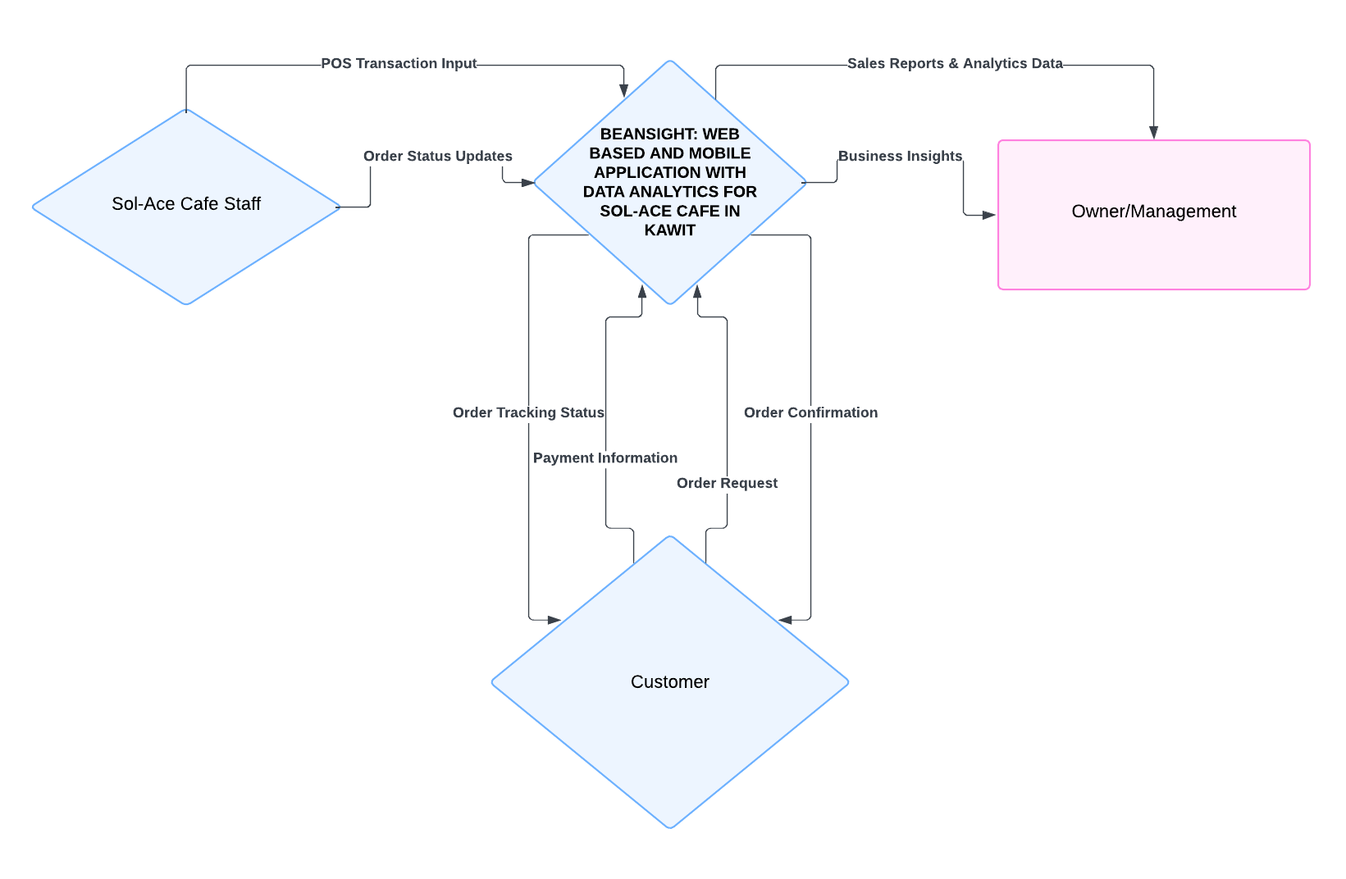Figure 2 Presents the Context Diagram for Beansight: a web based and mobile application with data analytics for sol-ace cafe

**Figure 2.** Context Diagram for Beansight

Figure 3 presents the use case diagram of Beansight: a web based and mobile application with data analytics for sol-ace cafe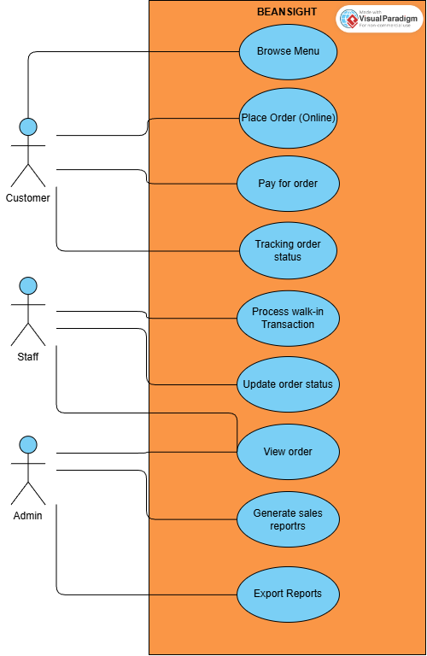

**Figure 3.** Use Case Diagram for Beansight

**Requirement analysis.** The researchers collected more information about the needs and requirements for Beansight in the requirements analysis phase. This phase was done through an interview with the owner of the cafe. The business current process is the usual manual order processing when a customer takes an order the cashier takes their order and processes it and takes their payments, then gives the customers’ orders.

Figure 4 presents the current manual ordering process of Sol-Ace Café

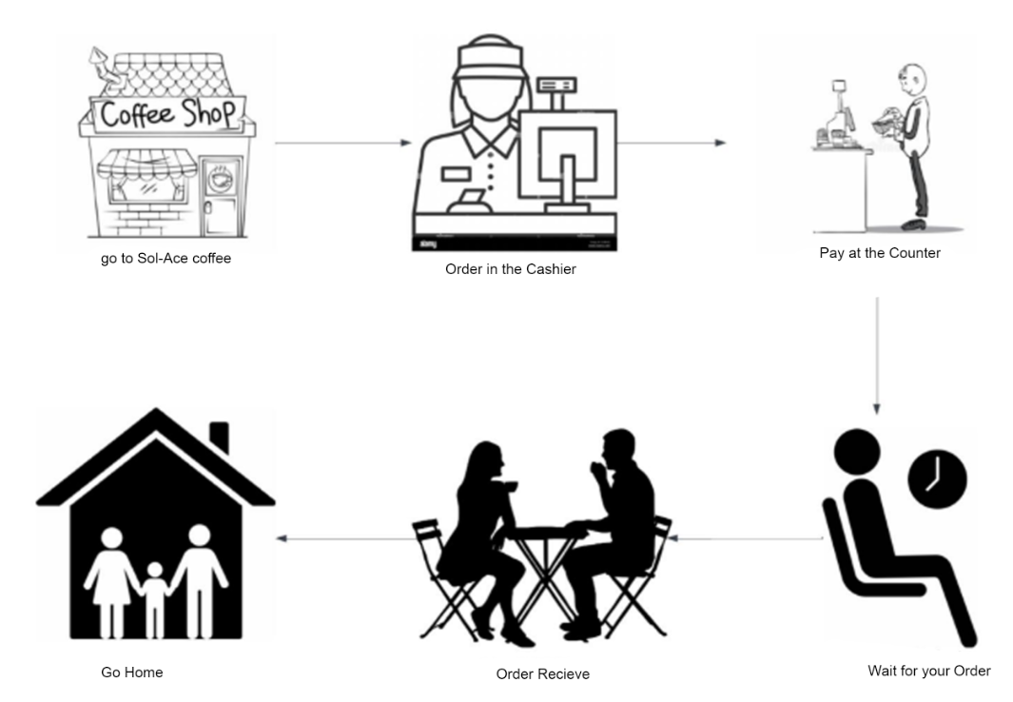

**Figure 4.** Manual Ordering Processing in Sol-Ace Cafe

**Table 2.** Technical Resources

|  |  |  |
| --- | --- | --- |
| **Category** | **Resource** | **Purpose** |
| Hardware | Tablet | For the POS that the cashier will use |
| Hardware | Thermal Printer | Used for printing receipts |
| Hardware | Wi-Fi Router | WiFi connectivity used to run the System |
| Hardware | Laptop | Used by cafe owner for reports and administrative tasks |
| Software | Microsoft Office | Used for reports and documentation |

**Table 3.** Estimated Cost of the Project

|  |  |
| --- | --- |
| **PARTICULARS** | **AMOUNT (P)** |
| 1. Domain (Yearly Subscription) | 840.00 |
| 1. Cloud Storage | 745.00 |
| **TOTAL** | 1585.00 |

**Requirement documentation.** The study focuses on the development of Beansight, a web-based and mobile application designed to enhance and unify the operations of Sol-Ace Café in Kawit. The system integrates multiple operational functions online ordering, Point of Sale (POS), sales reporting, order status tracking, and kitchen display into a single digital ecosystem. This unified approach aims to improve efficiency, accuracy, and customer satisfaction within the café’s daily operations. The tables 4 and 5 present the Functional and Non-Functional requirements of the system.

**Table 4.** Module and Features of the Proposed System

|  |  |
| --- | --- |
| **MODULE/FEATURES** | **DETAILED FUNCTION** |
| Ordering Module | 1. Enables customers to place their order and to browse the full menu, select. 2. Categorizes products for easy navigation. |
| Point of Sale (POS) Module | 1. Processes walk-in transaction. 2. Supports payment methods (cash, e-wallet like GCash). |
| Sales and Reporting Analytics | 1. Provides real-time dashboards of essential business metrics (revenue, best-selling products, customer trends) 2. Allows reports to be exported for management use. |
| Order Status Tracking | 1. Allows customers to monitor order progress (confirmation to completion). 2. Enables staff to update and manage order statuses. |
| Multi-Channel Integration | 1. Ensures online and in-store transactions are synchronized. 2. Maintains unified records for orders and payments. |

**Table 4.** Continued

|  |  |
| --- | --- |
| **MODULE/FEATURES** | **DETAILED FUNCTION** |
| Kitchen Display System | 1. Provides an interactive digital interface for kitchen staff. 2. Displays live order queues from walk-in and online sources. |

**Table 5.** Non-Functional Requirements of the System

|  |  |
| --- | --- |
| **QUALITY ATTRIBUTES** | **DESCRIPTION** |
| Functionality | The system shall be fully functional, enabling all core operations, including customer ordering, payment processing (POS), and synchronization with the KDS. This includes the capability to generate sales dashboards and export management reports via the administrative interface. |
| Usability | The system shall provide an intuitive interface for customers (Ordering Module) and staff (POS, KDS). The management/admin site for analytics must also be intuitive, allowing managers to easily navigate the dashboards and find specific metrics without extensive training. |
| Efficiency | The system shall work without crashes or errors, processing transactions and updating real-time data and analytics dashboards within acceptable time limits to ensure management has current information for decision-making. |
| Maintainability | The system should be structured to allow for easy modification, testing, and deployment of updates (e.g., menu changes, new payment methods) without extensive downtime. |
| Portability | The system's customer-facing interface and core components should be easily adapted to run effectively on different hardware devices |

## System Development

The development of the Beansight web application adapted the Agile model with 6 iterative stages which is the Planning, Design, Development, Testing, Evaluation and feedback, and Maintenance phase.

**Figure 5.** Agile Model (asana, 2025)

**Planning.** During this phase, the team gathered initial requirements from the coffee shop stakeholders. Key system functionalities were identified, such as order processing, POS integration, and customer interaction workflows.

**Designing.** Based on the requirements, system wireframes, database structures, and user interface designs were created. The Proponents ensured that the layout was user-friendly and aligned with the Sol-Ace coffee shop’s daily operational flow.

**Development.** System features were developed in short sprints. Core modules such as the ordering system, POS interface, and Admin page were implemented progressively. The Agile approach allowed the proponents to deliver functional components early and update them based on feedback.

**Testing.** After each sprint, the developed features underwent module and integration testing to ensure that they worked correctly and met the client’s expectations. Bugs and errors were documented and fixed immediately in the next iteration.

**Deployment.** The stable version of the application was deployed to a live cloud environment using Firebase Hosting. This process made the web application globally accessible via a URL, enabling the café owner, staff, and customers to access and test the system on their devices.

**Review.** In the final phase of the cycle, feedback was collected from the end-users (Owner and Staff) based on their interaction with the hosted application. This feedback was analyzed to identify areas for improvement, which served as the input for the next iteration of the cycle.

## System Testing

The system testing phase of Beansight: A Web-Based and Mobile Application with Data Analytics for Sol-Ace Café in Kawit is an ongoing process conducted to verify that all system components function as intended and meet the defined requirements. This phase focuses on identifying defects, ensuring feature reliability, and validating that each module operates correctly both individually and when integrated into the overall system.

Module testing is conducted on each core component of the system, including the Customer-Facing Ordering Module, the Staff POS and KDS Module, and the Administrative Management and Analytics Module. Each module is tested individually to verify that all functionalities, such as order placement, payment processing, sales reporting, and order status tracking, work correctly. Any issues detected during this stage are documented and addressed before integration, ensuring that each module meets its design specifications.

After individual modules are tested, integration testing is performed to evaluate the interaction between different system components. This ensures that data flows accurately between the ordering interface, POS, KDS, and analytics dashboard. Integration testing is crucial for identifying issues related to real-time synchronization, multi-channel updates, and inter-module communication, which are critical for the smooth operation of a unified system like Beansight.

## System Evaluation

The developed Beansight: A Web-Based and Mobile Application with Data Analytics for Sol-Ace Café in Kawit will go through evaluation to know its usability, functionality, efficiency, reliability, maintainability, portability, and its overall acceptability. The system is primarily used by the business owner which handles the admin side of the page and the staff which handles the orders and POS of the page and the Customers that orders on the Main Page, the evaluation will be conducted through a Survey with the users, who use the system.

A Survey will be used as the evaluation instrument. This survey will collect quantitative feedback regarding the system’s usability, functionality, efficiency, reliability, maintainability, portability, and its overall acceptability of users using the platform. Also, the survey will have 50 respondents. The results of the survey will help determine whether the system meets user needs and supports the operational goals of Sol-Ace Café.

**Table 6.** 5-point Likert Scale

|  |  |
| --- | --- |
| **SCALE** | **DESCRIPTION** |
| 5 | Strongly Agree |
| 4 | Agree |
| 3 | Neutral |
| 2 | Disagree |
| 1 | Strongly Disagree |

**Table 7.** Descriptive interpretation of the mean

|  |  |
| --- | --- |
| **NUMERICAL SCALE** | **INTERPRETATION** |
| 4.51 - 5.00 | Excellent |
| 3.51 - 4.50 | Very Good |
| 2.51 - 3.50 | Good |
| 1.51 - 2.50 | Fair |
| 1.50 - below | Poor |

**Statistical Treatment of Data.** The researchers employed statistical tools to analyze responses collected from the System Evaluation Questionnaire, which utilized a Likert scale. This approach ensured an objective assessment of the Beansight system across six key evaluation criteria: Usability, Functionality, Reliability, Efficiency, Maintainability, Portability, and Overall Satisfaction.

**Mean.** The weighted mean was used to determine the central tendency of respondents’ ratings for each system criterion. It was calculated using the formula:

$$X= \frac{\sum{(x⋅w)}}{N}$$

Where:

*X* = weighted mean

*x* = score assigned to each Likert system

*w* = frequency responses for that score

*N =* total number of respondents

**Standard Deviation.** Standard deviation measured the dispersion of responses, indicating how consistently respondents rated each system criterion. It was calculated as:

$$S= \sqrt{\frac{\sum{{\left(x-X\right)}^{2}}}{N}}$$

Where:

*S* = standard deviation

*x* = individual response value

*X* = mean of all responses

*N =* number of respondents

**Frequency and Percentage.** Frequency and percentage calculations described the distribution of ratings for each item, with percentage calculated as:

$$P= \frac{f}{n} ×50$$

Where:

*P* = percentage

*f* = frequency of a particular response

*n* = total number of respondents

By applying these statistical methods, the study provided a comprehensive and objective evaluation of Beansight’s Usability, Functionality, Efficiency, Maintainability, Portability, and Overall Satisfaction, supporting data-driven conclusions regarding the system’s effectiveness and areas for enhancement.

## Implementation Plan

The implementation plan outlines the step-by-step process to ensure the smooth deployment of Beansight, covering approval, technical setup, system testing, and user preparation. Each phase is designed to make the transition efficient for both the café staff and customers. By providing proper training, clear system guides, and gradual exposure to the platform, the proponents aim to ensure that the café can adopt the new system with confidence. This structured approach helps minimize disruptions, supports user familiarity, and ensures that Beansight is fully functional and ready for daily operations once launched.

**Table 8.** Implementation Plan of Beansight

|  |  |  |  |
| --- | --- | --- | --- |
| **STRATEGY** | **ACTIVITIES** | **PERSONS INVOLVED** | **DURATION** |
| Approval | Present the system proposal and secure permission to implement | Proponents, Café Owner | 1 day |
| System Installation | Set up the ordering, POS, analytics modules on the café’s devices | Proponents | 5 hours |
| Initial Testing | Test main functions like ordering, POS transactions, and sales reports | Proponents, Café Staff, Café Owner | 5 hours |
| Information Dissemination | Provide simple guides about the system | Proponents, Café Staff, Café Owner | 2 hours |
| Staff Training | Train staff on using the POS, managing orders, and checking reports | Proponents, Café Staff | 1 day |
| Customer Orientation | Show customers how to order and track using the app/website | Proponents, Café Staff | 1 day |
| Full Implementation | Launch the system for daily café operations | Proponents, Café Owner | 1 day |

# RESULTS AND DISCUSSION

## System Design

The system design is the result of a feature-driven approach, where validated requirements were translated directly into functional user interfaces. the design was constructed dynamically based on the feature requirements flow, allowing the interface layout to improve naturally alongside the logical sequence of sol ace café’s operations. This direct prototyping method ensured that every visual component from the ordering menu to the POS dashboard was built specifically to support the immediate functionality of the system modules.

Figure 6 shows the Three-Tier Architecture used in the system. The Presentation Tier includes the Customer, Staff, and Admin interfaces built using React and Tailwind. These connect to the Application Tier, where Firebase Services manage the user login and system logic. The Data Tier uses Cloud Firestore to store all information and sync orders in real-time across all devices.

**Figure 6.** System Architecture

Figure 7 presents the relational structure implemented in Cloud Firestore. The design utilizes a streamlined three-entity model: User, Orders, and Inventory. The Order entity serves as the central transaction record, establishing a One-to-Many relationship with the User (to track ownership) and a direct link to the Inventory (to identify purchased items). To optimize performance in the NoSQL environment, specific transaction details such as item quantity and size customization are processed within this relationship structure, ensuring efficient data retrieval for the sales reporting module.

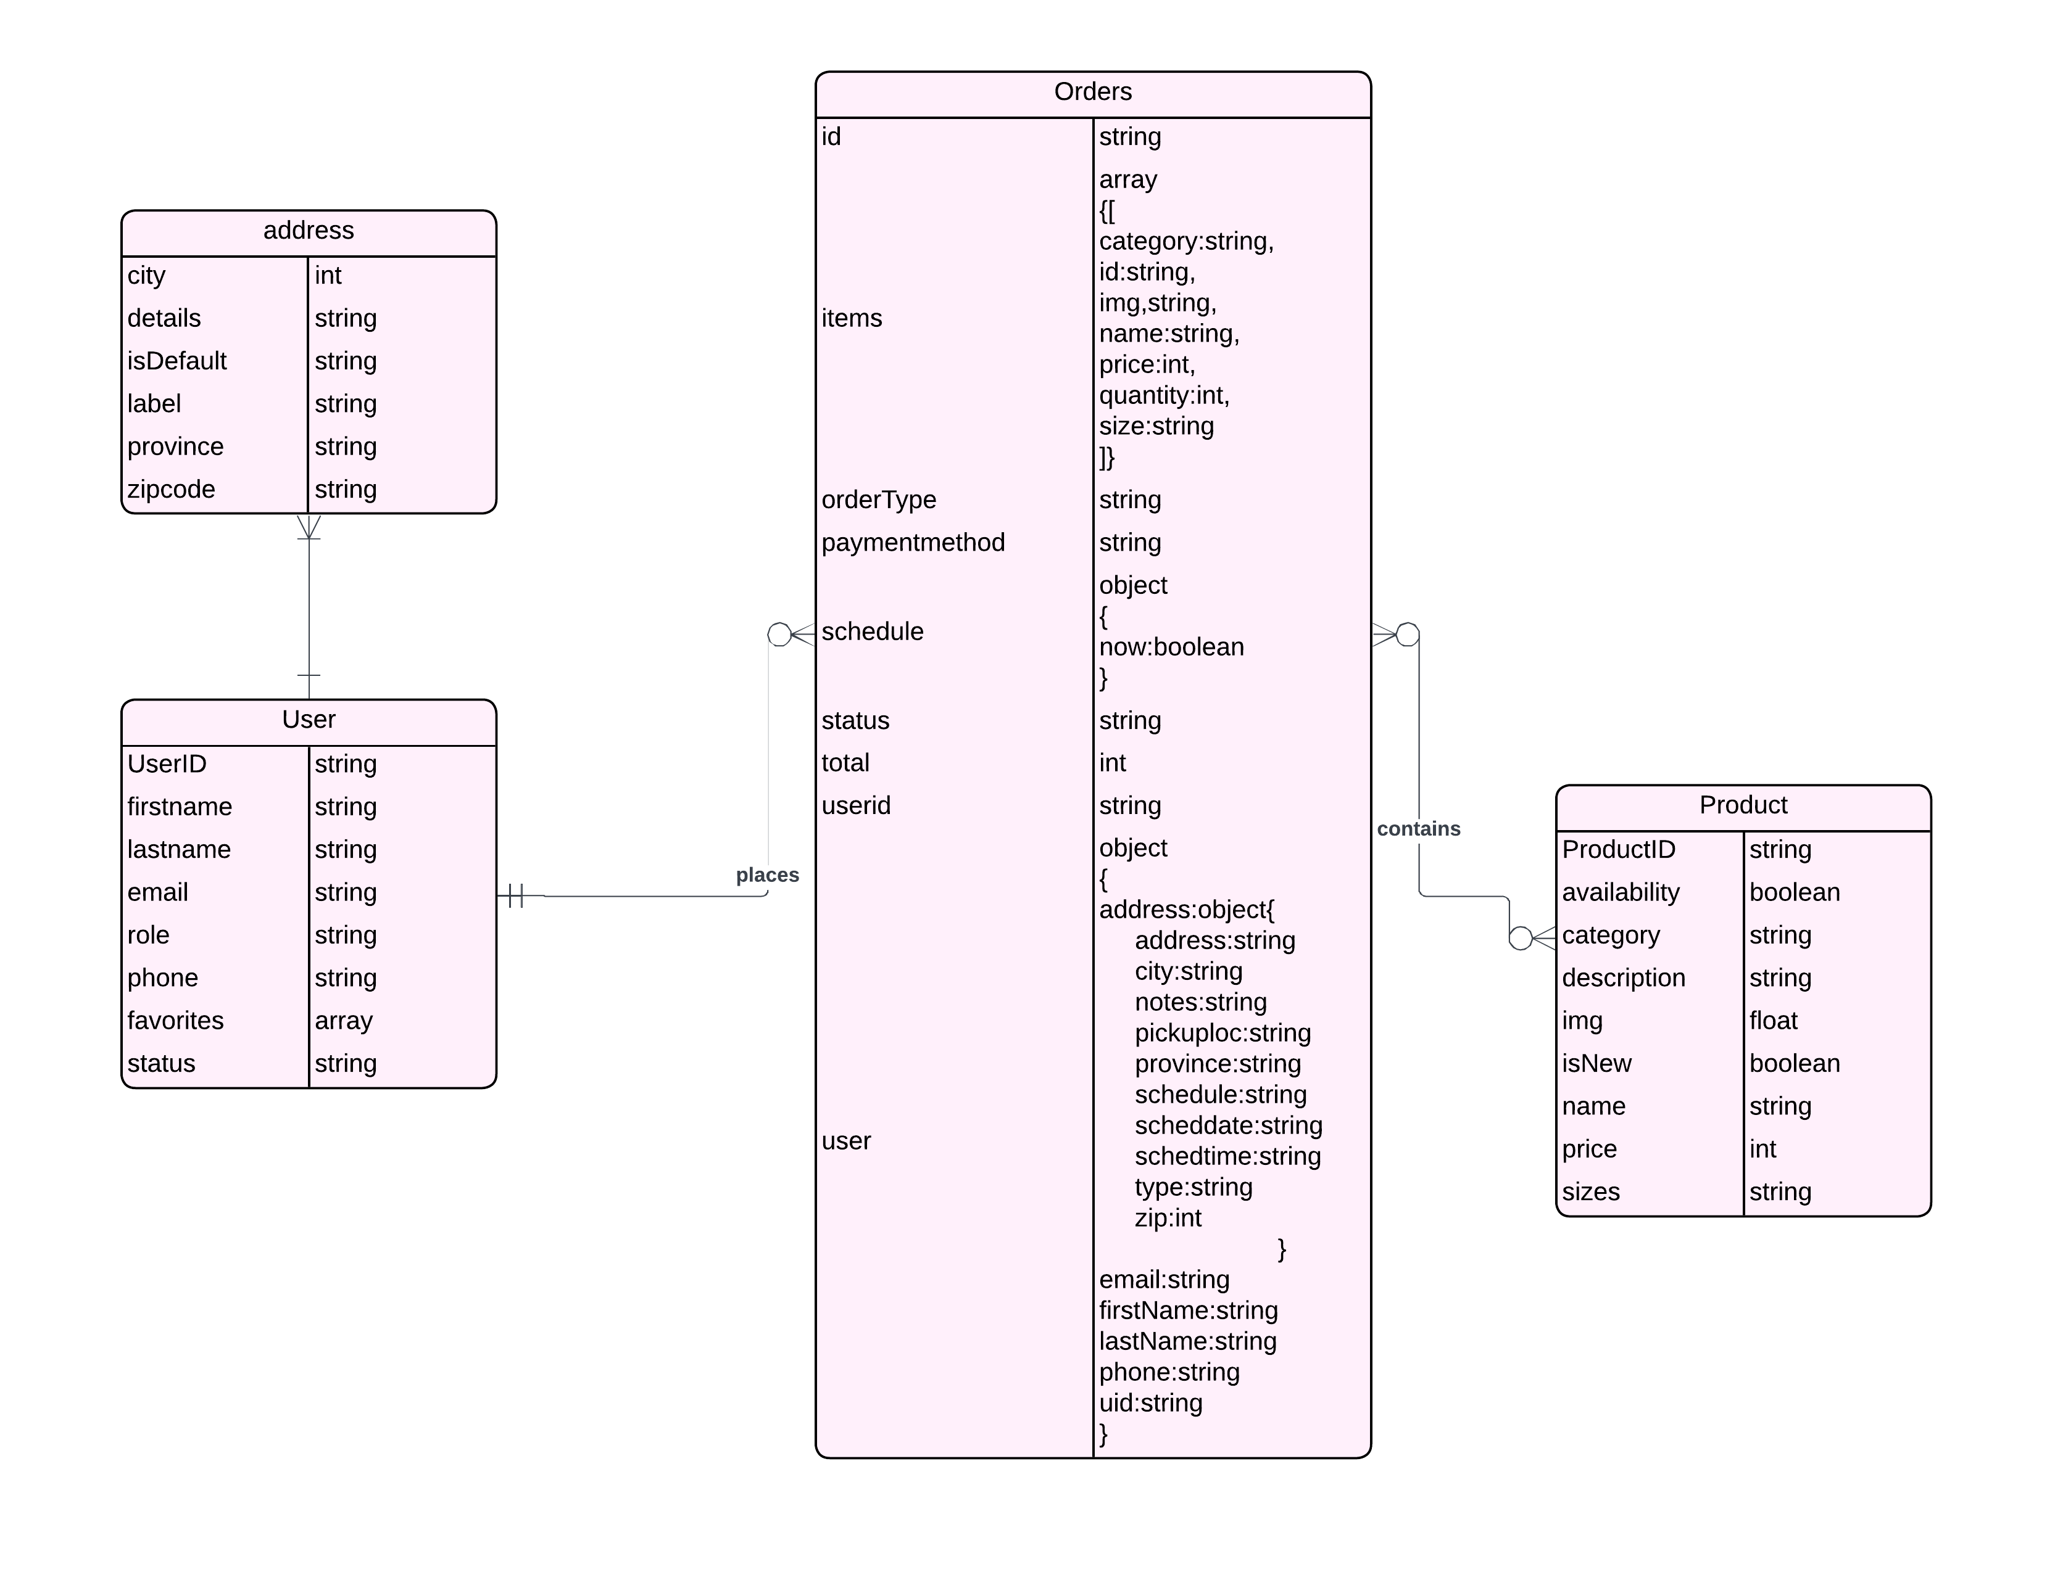

**Figure 7.** NoSQL Database Diagram of the System

To realize the operational flow proposed in the methodology, the researchers developed a responsive and intuitive user interface that follows the planned functional requirements. The design prioritizes ease of navigation for customers and rapid transaction processing for the staff.

Figure 8 presents the finalized Customer Menu Interface, which features a categorized layout to streamline the selection process. The interface includes a real-time "My Bag" sidebar that updates instantly when items are added, allowing users to review their subtotal before proceeding.

**Figure 8.** Customer Menu Interface

Following the selection, Figure 9 illustrates the Checkout Page. This interface integrates a location map to ensure accuracy for pickup or delivery and provides a clear order summary. The system automatically calculates the total amount, minimizing user error and ensuring a seamless transaction experience.

**Figure 9.** Checkout Page

To satisfy the objective of providing transparent monitoring, Figure 10 displays the Order Status Tracking Interface. This screen provides customers with real-time updates on their order status (e.g., "Pending," "Preparing," "Ready"), synced directly from the staffs interface activity.

**Figure 10**. Order Status Tracking Interface

Figure 11 illustrates the Point of Sale (POS) Interface designed for walk-in customers. As shown, the layout features a visual product grid for quick selection and an automated transaction calculator (Subtotal, Cash, Change) to reduce manual errors during peak hours.

**Figure 11.** Point of Sale (POS) Interface

Complementing the POS, Figure 12 presents the Kitchen Display System (KDS). This module functions as a live digital queue for the preparation staff, replacing traditional paper tickets. As demonstrated, the specific order #ORD-815028 (initially placed in Figure 10) appears instantly on this display with its status marked as "Pending." This confirms the system's ability to broadcast online orders directly to the kitchen in real-time, streamlining the preparation workflow.

**Figure 12.** Kitchen Display System

Finally, Figure 13 shows the Admin Analytics Dashboard. It displays a summary of the business, including Total Sales, Total Orders, and a graph for weekly revenue. Notably, "Mocha" is listed as the Top Selling Item, which matches the order made in the previous figures. This proves that the sales data from the Customer and Staff apps is successfully syncing to the admin panel.

**Figure 13.** Admin Analytics Dashboard

## System Development

The application used the Agile model for the development of beansight, which guided the proponents through an iterative process that ensured continuous refinement of the system after every testing procedure. Each phase contributed to the gradual improvement of the application, allowing the researchers to build, evaluate, and enhance the system in cycles until the expected functionality was achieved.

**Planning.** During the planning phase, the proponents gathered and validated the initial requirements from the Sol-Ace Café stakeholders. Important system functionalities such as order processing, POS integration, and customer interaction workflows were identified and documented. These requirements served as the foundation for the succeeding development activities.

**Designing.** In the design phase, the proponents adopted a feature-driven design approach, translating the validated requirements directly into functional user interfaces. The design was constructed dynamically based on the feature requirements flow, allowing the interface layout to evolve naturally alongside the logical sequence of the sol-ace café’s operations.

**Development.** The development phase involved the actual construction of the system features across multiple short sprints. Core modules including the Customer Ordering system, Staff POS interface, and Administrative Dashboard were progressively implemented and integrated using React and Firebase. Table 9 below shows the sprints that the proponents did to develop the system

**Table 9.** Sprint Cycle

|  |  |  |  |
| --- | --- | --- | --- |
| **SPRINT CYCLE** | **FOCUS AREA** | **KEY OBJECTIVES** | **ACHIEVED OUTPUTS** |
| SPRINT 1 | Customer Ordering Module | Develop the client-facing interface for browsing menus and placing orders. | * Fully functional **Menu Interface** with categories (Coffee, Non-Coffee, Frappe). * **Order Customization** logic (size, add-ons). * **Shopping Cart** and checkout functionality. * Initial **Firebase Firestore** database implementation. |
| SPRINT 2 | Staff POS & KDS Integration | Create the in-store system for staff to manage orders and process payments. | * **Point of Sale (POS)** interface for walk-in transactions. * Real-time **Kitchen Display System (KDS)** syncing with online orders. * Integration of payment recording (Cash/E-wallet). |
| SPRINT 3 | Admin Dashboard & Analytics | Implement management tools for sales tracking and inventory control. | * **Admin Dashboard** with secure login. * **Sales Reporting Module** generating real-time data on revenue and top-selling items. * **Inventory Management** system to update product availability. |
| SPRINT 4 | System Integration & Testing | Ensure all modules communicate correctly and fix identified bugs. | * **Multi-Channel Synchronization** (Online orders instantly appear on POS/KDS). * Resolution of bugs found in initial testing. * Final UI/UX refinements based on operational flow. |

**Testing Overview.** Throughout the development process, the proponents conducted comprehensive unit and integration testing to verify the functionality, accuracy, and system compatibility of each developed feature. Specifically, the researchers performed Module Testing on the Customer, Staff, and Admin interfaces, followed by Integration Testing to confirm real-time data synchronization. Identified bugs, errors, and inconsistencies were resolved in the immediate next iteration. This process ensured that the system improved continuously and that the core features achieved stability prior to the final deployment.

## System Testing

System Testing Results. The results of the integration testing, as summarized in Table 10 and Table 11, confirmed the functionality, accuracy, and system compatibility of the developed features. Specifically, the Module Testing results demonstrated that the Customer, Staff, and Admin interfaces successfully met all functional requirements. Furthermore, Integration Testing verified the system’s capability for real-time data synchronization across all platforms. While initial testing identified minor inconsistencies, the iterative resolution process resulted in a fully stable system ready for deployment, as evidenced by the final passing status of all test cases.

Table 10 presents the summary of the functionality testing conducted on the core modules of Beansight. As shown, all critical features from user registration to sales reporting were successfully tested and achieved a passing status.

**Table 10.** Summary of Module Functionality Testing

|  |  |  |  |
| --- | --- | --- | --- |
| **MODULE** | **FEATURE TESTED** | **EXPECTED OUTPUT** | **STATUS** |
| Customer Interface | Account Registration | User account created and stored in Firebase | Pass |
| Add Address | Address added using google maps API | Pass |
| User Login | Customer Redirects to Home landing page | Pass |
| Menu Browsing | Menu Loads with correct products and categories | Pass |
| Add to Cart | Selected item appears in cart with correct price | Pass |
| Checkout Process | Order is placed and status changes to "Pending" | Pass |
| Staff Interface | User Login | Staff Redirects to POS | Pass |
| Input Orders | Staff can manually input orders using the POS, accept payment, and print receipts | Pass |
| Manage Online Orders | Manage online orders using the Kitchen Display | Pass |
| Manage Products | Change products availability | Pass |

**Table 11.** Continued

|  |  |  |  |
| --- | --- | --- | --- |
| **MODULE** | **FEATURE TESTED** | **EXPECTED OUTPUT** | **STATUS** |
| Admin Interface | User Login | Admin Redirects to Admin Page | Pass |
| Dashboard Analytics | Displays the overview of the business performance | Pass |
| Product Management | Allows the admin to add, edit, and delete products | Pass |
| Inventory Management | Allows admin to monitor and add stocks | Pass |
| Order Management | Allows admin to view and print order history | Pass |
| User Management | Allows admin to manage staffs accounts | Pass |
| Reports | Allows admin to export overall reports and customized reports | Pass |
|  | System Configuration | Allows admin to manage the configuration of the system such as Store preferences, Advertisement banners, map settings, and analytics settings | Pass |

Table 11 shows the Integration testing focused on the multi-channel capabilities of the system. The results below confirm that the Firebase Realtime Database successfully synchronized data across the Customer, Staff, and Admin interfaces with no significant latency.

**Table 11.** Integration Testing Results

|  |  |  |  |
| --- | --- | --- | --- |
| **INTEGRATION TESTING** | **TEST SCENARIO** | **ACTUAL RESULT** | **STATUS** |
| Customer to KDS | Customer places an online order. | Order received on Staff page; Order added to queue. | Passed |
| KDS to Customer | Staff updates order to "Ready". | Customer receives status update on the order page. | Passed |
| POS to Admin DB | Staff completes a transaction. | Sales Dashboard updates total revenue immediately. | Passed |
| Admin to Menu | Admin updates product price. | New price reflects on Customer and Staff Apps instantly. | Passed |
| Admin to Staff and Customer Interface | Admin modifies global settings (e.g., Store Availability, Ads, or Maps). | Changes are reflected immediately on the Customer and Staff interfaces. | Passed |

## System Evaluation

In order to obtain the evaluation result, the proponents conducted a software evaluation to 50 participants in Sol-Ace Café in kawit which are the customers and the owner of sol-ace café.

Table 12 presents the distribution of the respondents who participated in the evaluation of Beansight. The study involved a total of 50 respondents, composed of the Sol-Ace Café business owner and the customers.

**Table 12.** Survey Respondents

|  |  |  |
| --- | --- | --- |
| **CATEGORY** | **FREQUENCY** | **PERCENTAGE (%)** |
| Customers | 49 | 98**%** |
| Owner | 1 | 2**%** |
| **Total** | **50** | **100%** |

Table 13 reveals a weighted mean of 4.47 "Very Good", with the standard deviation ranged from 0.70 to 0.81 indicating consistent feedback. The highest rating went to Item #2 for accurate order processing 4.54, "Excellent", validating the system's core logic. Additionally, Item #6 4.50 confirmed strong user confidence in data security. These results demonstrate that Beansight effectively meets its functional requirements, particularly in accuracy and safety.

**Table 13.** General Rating on Functionality

|  |  |  |
| --- | --- | --- |
| **FUNCTIONALITY INDICATORS** | **MEAN SCORES** | **INTERPRETATION** |
| All features necessary for ordering are functioning properly. | 4.36 | Very Good |
| The system processes my orders correctly. | 4.54 | Excellent |
| The system displays complete and accurate information about menu items. | 4.42 | Very Good |
| The system works as expected when ordering or tracking an order. | 4.50 | Very Good |
| The system features respond correctly to user inputs | 4.48 | Very Good |
| The system provides strong data security for user information | 4.50 | Very Good |
| **Weighted Mean** | **4.47** | **Very Good** |

Table 14 reveals a weighted mean of 4.44 "Very Good" for reliability, with standard deviations ranging from 0.65 to 0.81. This narrow variance indicates a strong user consensus regarding the system's stability. Item #3 received the highest rating (4.54, "Excellent"), suggesting minimal system failures, while Item #4 recorded the highest level of agreement with the lowest deviation (0.65). Overall, the consistent scores confirm that Beansight is a dependable platform for daily operations.

**Table 14.** General Rating on Reliability

|  |  |  |
| --- | --- | --- |
| **RELIABILITY INDICATORS** | **MEAN SCORES** | **INTERPRETATION** |
| The system runs smoothly without freezing or crashing. | 4.24 | Very Good |
| The system consistently displays correct products and orders. | 4.52 | Excellent |
| The system can save progress even during unexpected interruptions. | 4.54 | Excellent |
| The system’s content loads properly every time it is accessed. | 4.46 | Very Good |
| **Weighted Mean** | **4.44** | **Very Good** |

Table 15 shows that Usability achieved the highest weighted mean among all criteria (4.56, "Excellent"), with standard deviations ranging from 0.57 to 0.86. This low deviation indicates a strong user consensus on the system's ease of use. The highest rating went to Item #1 (*"*visually appealing design*"*) at 4.60, which also recorded the lowest standard deviation (0.57), proving near-unanimous agreement on the intuitive interface. Items #3 and #4 followed closely (4.58), confirming clear navigation and confusion-free ordering. Overall, these scores validate that the design successfully prioritized user experience.

**Table 15.** General Rating on Usability

|  |  |  |
| --- | --- | --- |
| **USABILITY INDICATORS** | **MEAN SCORES** | **INTERPRETATION** |
| The design is visually appealing and user-friendly | 4.60 | Excellent |
| The system is easy to navigate and understand. | 4.48 | Very Good |
| The buttons, texts, and labels are understandable. | 4.58 | Excellent |
| I can place an order without confusion or difficulty. | 4.58 | Excellent |
| **Weighted Mean** | **4.56** | **Excellent** |

Table 16 indicates that the system’s Efficiency achieved a weighted mean of 4.39 ("Very Good"), with standard deviations ranging from 0.61 to 0.85. This range suggests a generally consistent user experience, though slightly more varied than the Usability results. The highest rating was given to Item #3 (*"*system responds immediately*"*) at 4.46, which also recorded the lowest standard deviation (0.61), proving strong consensus on the app's responsiveness. While Item #1 (*"*loads pages quickly*"*) received the lowest mean of 4.28, the high score for Item #4 (4.44) confirms that users still found the digital process significantly more efficient than manual ordering.

**Table 16.** General Rating on Efficiency

|  |  |  |
| --- | --- | --- |
| **EFFICIENCY**  **INDICATORS** | **MEAN SCORES** | **INTERPRETATION** |
| The system loads pages quickly. | 4.28 | Very Good |
| The order process is fast and convenient. | 4.36 | Very Good |
| The system responds immediately to my actions. | 4.46 | Very Good |
| The system helps me order more efficiently compared to manual ordering. | 4.44 | Very Good |
| **Weighted Mean** | **4.39** | **Very Good** |

Table 17 indicates a weighted mean of 4.35 ("Very Good"), with standard deviations ranging from 0.75 to 0.94. The highest rating went to Item #1 (4.38) for quick menu updates, confirming the effectiveness of the Firebase Realtime Database synchronization. However, Item #2 received the lowest score (4.32) and the highest standard deviation (0.94), suggesting that while the majority found the system stable, a few users experienced minor issues. Overall, the system is robust enough for deployment, though the variance points to areas for future optimization.

**Table 17.** General Rating on Maintainability

|  |  |  |
| --- | --- | --- |
| **MAINTAINABILITY**  **INDICATORS** | **MEAN SCORES** | **INTERPRETATION** |
| When the cafe updates the menu or changes prices, those changes are reflected quickly and accurately across the web/mobile ordering and POS systems. | 4.38 | Very Good |
| The system is stable and reliable; unexpected errors, crashes, or data loss occur rarely, if ever. | 4.32 | Very Good |
| **Weighted Mean** | **4.35** | **Very Good** |

Table 18 shows that Portability achieved a weighted mean of 4.55 ("Excellent"), with standard deviations ranging from 0.65 to 0.70. This low variance confirms a strong consensus that the system is highly accessible. The highest-rated indicator was Item #3 (*"*accessed anytime and anywhere*"*) with a mean of 4.62, validating the web-based architecture's advantage in providing remote access. Items #1 and #2 both received a score of 4.52, confirming that the responsive design (React/Tailwind) successfully adapted the interface to various devices and operating systems without compatibility issues.

**Table 18.** General Rating on Portability

|  |  |  |
| --- | --- | --- |
| **PORTABILITY INDICATORS** | **MEAN SCORES** | **INTERPRETATION** |
| The system runs smoothly on different devices (Phone, Tablet, PC). | 4.52 | Excellent |
| The system is compatible with various operating system (Android, Windows, etc.). | 4.52 | Excellent |
| The system can be easily accessed anytime and anywhere. | 4.62 | **Excellent** |
| **Weighted Mean** | **4.55** | **Excellent** |

Table 19 reveals that Overall Satisfaction achieved a weighted mean of 4.47 ("Very Good"), with standard deviations ranging from 0.71 to 0.81. This strong score indicates that Beansight successfully met the expectations of its stakeholders. The highest rating was given to Item #1 (4.48), confirming that users were satisfied with the general performance of the application. Item #2 followed closely at 4.46, validating that the features delivered aligned well with the user requirements. The low standard deviation further confirms that the positive reception was consistent across the customer respondent groups.

**Table 19.** General Rating on Overall Satisfaction

|  |  |  |
| --- | --- | --- |
| **OVERALL SATISFACTION**  **INDICATORS** | **MEAN SCORES** | **INTERPRETATION** |
| I am satisfied with the overall performance of Beansight. | 4.48 | Very Good |
| Overall, the system meets my expectations as a user. | 4.46 | Very Good |
| **Weighted Mean** | **4.47** | **Very Good** |

# SUMMARY, CONCLUSIONS, AND RECOMMENDATIONS

## Summary

The primary objective of this study was to develop and implement "Beansight," a web-based and mobile application designed to enhance operational efficiency and customer experience for Sol-Ace Café in Kawit, Cavite. Specifically, the study aimed to design a user-friendly system facilitating online ordering, real-time tracking, and dynamic sales reporting, utilizing JavaScript, React, and Tailwind CSS for the frontend and Firebase for the backend under an Agile development methodology. The development process successfully produced a functional Three-Tier Architecture system comprising a Customer Ordering App, a Staff POS with a Kitchen Display System (KDS), and an Admin Dashboard. Testing results confirmed that the Firebase Realtime Database effectively synchronized data across all modules with no significant latency, fulfilling the objective of multi-channel integration. Furthermore, the user evaluation yielded an Overall Weighted Mean of 4.46, interpreted as "Very Good" based on ISO 25010 standards, with Usability (4.56) and Portability (4.55) receiving the highest ratings, confirming the system's intuitive design and cross-platform accessibility.

## Conclusion

Based on the findings, the study concludes that Beansight successfully digitizes and streamlines the daily operations of Sol-Ace Café by replacing manual processes with a unified, real-time platform. The integration of the Online Ordering and POS modules allows for seamless transaction handling, directly addressing the need to synchronize online and in-store sales while reducing operational errors. The chosen technology stack, utilizing React and Firebase, proved to be a robust solution that delivered a highly responsive and secure interface, as evidenced by the "Excellent" usability ratings. Additionally, the implementation of the Sales Reporting and Analytics Module empowers the business owner with accessible, data-driven insights for better decision-making. With a functionality test pass rate of 100% and high reliability scores, the system is technically sound, reliable, and ready for full deployment in the live business environment.

## Recommendation

The following is hereby recommended to further enhance the study;

1. Add Loyalty Point System
2. Mobile app Supports IOS devices
3. Chatbot for Customer Support
4. Automatic Inventory Tracking

# REFERENCES

Almonteros, J., Cirera, M., Coddy, J., & Mendoza, D. (2024). *Investigating customer perception, e-satisfaction, and continuance intention to use of the Food Panda delivery application*. *Proceedings of the 2024 International Conference on Innovative Research in Applied Science, Engineering and Technology (IRASET).*<https://doi.org/10.1109/IRASET60544.2024.10548301>

Asana. (2025). *What is Agile methodology?* Retrieved from <https://asana.com/resources/agile-methodology>

Babasa, J., Fornolles, K., Marcos, E., & Zalameda, C. (2025). *COSY: An ordering web application system for school canteens*. *iCONNECT Multidisciplinary Research Journal, 2*(1), 40–48.  
[Philippine EJournals| COSY: An Ordering Web Application System For School Canteens](https://ejournals.ph/article.php?id=25411)

Buenaventura, R. U., Ignacio, A. E., & Laspoña, J. A. S. (2021). M*obile ordering application for a generic fast food restaurant*. *International Journal of Multidisciplinary: Applied Business and Education Research, 2*(5), 371–380.<https://doi.org/10.11594/ijmaber.02.05.01>

Dela Peña, G. B., & Aquino, J. M. (2023). *An analysis of customer perception on self-ordering kiosks of fast-food restaurants in San Pablo City, Laguna*. *Business, Organizations and Society, 1*(1), 1–7.<https://doi.org/10.26480/bosoc.01.2023.01.07>

Jiangmin, L. (2024). Development of a Web-based Food Ordering System. *Asia Pacific Journal of Management and Sustainable Development, 12*(2 Part 3), 152-156.  
[Philippine EJournals| Development of a Web-based Food Ordering System](https://ejournals.ph/article.php?id=25951)

Londoño-Giraldo, B., López-Ramírez, Y. M., & Vargas-Piedrahita, J. (2024). *Engagement and loyalty in mobile applications for restaurant home deliveries*. *Heliyon, 10*(7), e28289.<https://doi.org/10.1016/j.heliyon.2024.e28289>

Madani, B., & Alshraideh, H. (2021). Predicting consumer purchasing decisions in the online food delivery industry [Preprint]. *arXiv.*<https://arxiv.org/abs/2110.00502>

Maulana, W. (2023). Development and analysis of a unified mobile app for coffee shop operations and ordering experience: A proposal review. *International Journal of Information Technology and Computer Science Applications (IJITCSA), 1*(3), 161–173.  
[International Journal of Information Technology and Computer Science Applications (JITCSA)](https://pdfs.semanticscholar.org/d800/44776fe0fe5080c4a2864c7a9bb084350d58.pdf)

Rombach, M., Kartikasari, A., Dean, D. L., Suhartanto, D., & Chen, B. T. (2023). Determinants of customer loyalty to online food service delivery: Evidence from Indonesia, Taiwan, and New Zealand. *Journal of Hospitality Marketing & Management, 32*(6), 818–842. [https://doi.org/10.1080/19368623.2023.22110](https://doi.org/10.1080/19368623.2023.2211061)

Samoggia, A., Monticone, F., & Bertazzoli, A. (2021). Innovative digital technologies for purchasing and consumption in urban and regional agro-food systems: A systematic review. *Foods, 10*(2), 208.<https://doi.org/10.3390/foods10020208>

Samaniego, J. A., Tuazon, P., Ubuñgen, A. B., Vaño, V., Bandojo, A., & Nagal, K. C. (2022). Influence of mobile food delivery experience on customer reuse intention during the COVID-19 pandemic.  
[(PDF) Influence of Mobile Food Delivery Experience on Customer Reuse Intention during Covid-19 Pandemic](https://www.researchgate.net/publication/360757024_Influence_of_Mobile_Food_Delivery_Experience_on_Customer_Reuse_Intention_during_Covid-19_Pandemic)

Smith, A. G. (2022). Buy-online-pickup-in-store (BOPIS) business strategy: A multivariate study of BOPIS influencing factors on customer satisfaction (Honors thesis No. 257). University of South Dakota.<https://red.library.usd.edu/honors-thesis/257>

Wikamulia, N., & Isa, S. M. (2023). Predictive business intelligence dashboard for food and beverage business. *Bulletin of Electrical Engineering and Informatics, 12*(5), 3016–3026.<https://doi.org/10.11591/eei.v12i5.5162>

# APPENDICES

## Appendix 1. Relevant Source Code

## Appendix 2. Evaluation Instrument

**EVALUATION INSTRUMENT FOR BEANSIGHT: WEB BASED AND MOBILE APPLICATION WITH DATA ANALYTICS FOR SOL-ACE CAFÉ IN KAWIT**

**Name(optional):**  **Date:**

**Are you a?**(    )**Customer**(    )**Staff**(    )**Administrator**

**Gender:** **Male**  **Female**

**General Direction:** Please accomplish this questionnaire very carefully and honestly. Please rest assured that any information that you supply will be treated with the greatest confidentiality and anonymity.

|  |  |
| --- | --- |
| **RATING** | **EQUIVALENT** |
| **5** | **Strongly Agree** |
| **4** | **Agree** |
| **3** | **Neutral** |
| **2** | **Disagree** |
| **1** | **Strongly Disagree** |

|  |  |  |  |  |  |
| --- | --- | --- | --- | --- | --- |
| **Question** | **5** | **4** | **3** | **2** | **1** |
| 1. **Functionality** |  |  |  |  |  |
| 1. All features necessary for ordering are functioning properly. |  |  |  |  |  |
| 1. The system processes my orders correctly. |  |  |  |  |  |
| 1. The system displays complete and accurate information about menu items. |  |  |  |  |  |
| 1. The system works as expected when ordering or tracking an order. |  |  |  |  |  |
| 1. The system features respond correctly to user inputs |  |  |  |  |  |
| 1. The system provides strong data security for user information |  |  |  |  |  |
| 1. **Reliability** |  |  |  |  |  |
| 1. The system runs smoothly without freezing or crashing. |  |  |  |  |  |
| 1. The system consistently displays correct products and orders. |  |  |  |  |  |
| 1. The system can save progress even during unexpected interruptions. |  |  |  |  |  |
| 1. The system’s content loads properly every time it is accessed. |  |  |  |  |  |
| 1. **Usability** |  |  |  |  |  |
| 1. The design is visually appealing and user-friendly. |  |  |  |  |  |
| 1. The system is easy to navigate and understand |  |  |  |  |  |
| 1. The buttons, texts, and labels are understandable. |  |  |  |  |  |
| 1. I can place an order without confusion or difficulty. |  |  |  |  |  |
| 1. **Efficiency** |  |  |  |  |  |
| 1. The system loads pages quickly. |  |  |  |  |  |
| 1. The order process is fast and convenient. |  |  |  |  |  |
| 1. The system responds immediately to my actions. |  |  |  |  |  |
| 1. The system helps me order more efficiently compared to manual ordering. |  |  |  |  |  |
| 1. **Maintainability** |  |  |  |  |  |
| 1. When the cafe updates the menu or changes prices, those changes are reflected quickly and accurately across the web/mobile ordering and POS systems. |  |  |  |  |  |
| 1. The system is stable and reliable; unexpected errors, crashes, or data loss occur rarely, if ever. |  |  |  |  |  |
| 1. **Portability** |  |  |  |  |  |
| 1. The system runs smoothly on different devices (Phone, Tablet, PC). |  |  |  |  |  |
| 1. The system is compatible with various operating system (Android, Windows, etc.). |  |  |  |  |  |
| 1. The system can be easily accessed anytime and anywhere. |  |  |  |  |  |
| 1. **Overall Satisfaction** |  |  |  |  |  |
| 1. I am satisfied with the overall performance of Beansight. |  |  |  |  |  |
| 1. Overall, the system meets my expectations as a user. |  |  |  |  |  |

**Comments/Suggestions:**

**(Evaluator’s Signature)**

## Appendix 3. Sample input/output/reports

## Appendix 4. User’s guide

**USER’S MANUAL**

1. Customer Guide
2. Creating an account
   * + - A screenshot of a menu

         AI-generated content may be incorrect.Open the Beansight web application on your browser.
       - Click the **"Sign Up"** button on the landing page.
       - A screenshot of a computer

         AI-generated content may be incorrect.Enter your Full Name, Email Address, .
       - Click **"Create Account."** You will be redirected to the Home Page.
3. Placing an Order

* Navigate to the "Menu" tab.
* A screenshot of a menu

  AI-generated content may be incorrect.Browse items by category

.

* A screenshot of a website

  AI-generated content may be incorrect.Select an item (e.g., Mocha).
* Customize your order with add-ons if applicable.
* Click "Add to My Bag
* Go to your Cart (Bag Icon) to review your items.
* Click "Checkout." Select your Payment Method (Cash/GCash) and Order Type (Pickup).

* Click "Place Order."

1. **Tracking Your Order**

* After placing an order, you will be redirected to the **"My Orders"** page.
* View the status label on your active order card.
  + **Pending:** The store has received your order.
  + **Preparing:** The kitchen is currently making your drink.
  + A screenshot of a website

    AI-generated content may be incorrect.**Ready:** Your order is ready for pickup at the counter.

## A diagram of a company AI-generated content may be incorrect.Appendix 5. Process/data/information flow

## Appendix 6. Screen layouts

## Appendix 7. Request for adviser and technical critic

## Appendix 8. Gannt Chart

## Appendix 9. Budgetary requirements

## Appendix 10. Request for proposal defense

## Appendix 11. Proposal defense evaluation

## Appendix 12. Proposal approval sheet

## Appendix 13. Routing slip before ERB

## Appendix 14. Request for final defense

## Appendix 15. Form of the certification of completion

## Appendix 16. Final manuscript routing slip

## Appendix 17. Certification from English critic